Pilgrimage 2026 | Shrine of the Most Blessed Sacrament & EWTN Studios
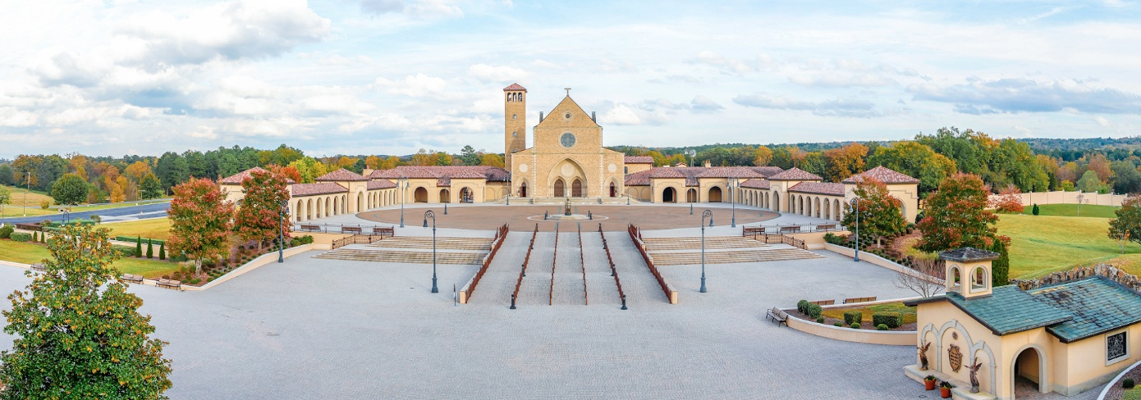
Monday, March 16, 2026: 8:00am Departure from Holy Family Church, 1001 Georgetown Ave, Copperas Cove. Lunch on your own in Longview, TX. Overnight in Pearl, MS. Dinner included.
Tuesday, March 17, 2026: Depart Pearl, MS, drive to the Shrine of the Most Blessed Sacrament, Hanceville, AL. The Shrine is the perfect place to experience renewal and grow together in friendship and community. Overnight Cullman, AL. All meals included.

Wednesday, March 18, 2026: Depart 8:30am, drive to EWTN Television Studios in Irondale, AL. Spiritual Talk with Fr. Joseph Mary Wolf, Tour of EWTN Studios, Mass, Confessions available, attend live studio audience for EWTN Live with Fr. Mitch Pacwa. Overnight Cullman, AL. All meals included.
Thursday, March 19, 2026: Shrine of the Most Blessed Sacrament; Mass, Tours, Eucharistic Talk, Rosary, Divine Mercy with the Nuns, JPII Center, Lourdes Grotto Shrine, Stations of the Eucharist and Healing Service. Overnight Cullman, AL. All meals included.
Friday, March 20, 2026: 9:00am Depart Cullman, AL, lunch on your own in Jackson, MS. Overnight in Bosier City, LA. Dinner included.
Saturday March 21, 2026: 9:00am Depart hotel after breakfast, arrive at Holy Family Church, Copperas Cove, TX apx 1:30pm. Trip ends.
Pilgrimage cost is $755 per person/double occupancy rooms. Roundtrip motor coach, transportation to all event and meals are included (except lunches on 3/16/26 & 3/20/26).
For more detailed questions, call Anne Marie McNew at 630-747-3750.

